OLD VERSION

**Background**

Stream-lake linkages are crucial interfaces which influence both the transport of nutrients and biotic responses. Evidence supports the idea that lakes act differentially as sinks and sources of dissolved organic matter, depending on hydrologic conditions (Goodman et al 2011, Robinson et al 2007, Xu & Xu 2018).

* Importance of watershed characteristics on waterbody condition
  + Terrestrial-aquatic linkages
  + Stream-lake linkages and watershed connectivity
    - Marcarelli & Wurtsbaugh 2009
      * Seasonality in nitrogen fixation, temporal variability in nitrogen fixation. Higher amount of fixation in lakes due to larger surface area, but higher rates in streams
    - Stachelek & Soranno 2019
      * P retention in lakes influenced by hydrologic connectivity within the whole lake watershed, but not as strongly within subwatersheds
        + Higher p retention in lakes with less upstream lake area (less flushing?)

Applied to BVR-FCR system: BVR would have higher P retention than FCR if BVR outflow is flowing into FCR

i.e., there will be less P at the

* + - Wurtsbaugh 2005
      * Can’t get access to…
    - Sadro et al 2012
      * Shows importance of landsape connectivity in explaining biogeochemical responses within snowmelt dominated landscape
      * Directly measures response of various nutrient chem variables to lake network number
    - Kling et al 2000
      * Studies a lake chain at Toolik station in Alaska
      * Found primary productivity, particulate C, N, P all show slight decreases with increasing lake chain #
        + But there were >8 lakes in this chain
      * This is a low-productivity, snowmelt dominated landscape
      * Lakes consumer CO2, CH2, alkalinity, DIC, Ca, Mg, and NO3 while streams produce these things (at approximately the same rates!)
      * Inlet vs. outlet of lakes were statistically different in the variables measured, same for upstream vs. downstream locations
        + Meaning there is processing going on in both stream and lake ecosystems
        + But at what scale?
    - Schmadel et al 2018
    - Soares et al 2012
      * Decrease in nutrients from lotic to lentic within reservoir
      * Increase in phytoplankton from lotic to lentic
        + Not limited by nutrients in lotic zone, but by residence time
    - Jones 2010
* Importance of hydrologic variance in nutrient dynamics
  + - Robinson et al 2007
      * Seasonality in nutrient availability due to weather patterns (nutrients coming from glacier melt are reduced in autumn-on)
    - Brown et al 2008
      * Seasonality of lakes as sinks or sources of nitrogen
      * SO why have we seen something different in FCR? What is FCR almost always a sink and not a source? Reservoir vs. lake difference?
    - Goodman et al 2011
      * Lakes act as sinks during high flow conditions and sources during low flow conditions
    - HOWEVER, we see in Gerling et al 2016 that FCR functions almost always as a sink
      * Only time we see FCR function as a source is during hypoxic-low flow conditions (NH4 only)
      * External loading is primary source of NO3NO2 to FCR in contrast to other nutrients
    - Xu & Xu 2018
      * DIC significantly decreased after passing through lake
      * Propose that CO2 outgassing is mechanism for sink behavior of lake
      * Lake functions as sink during high flow and source during low flow, consistent with other studies
* So, in summary, some other things I’m expecting to see both lake chain/connectivity effects and residence time/hydrologic variability effects.
  + Question 1: How does hydrologic connectivity and reservoir continuum location (need some wordsmithing) influence nutrient availability and phytoplankton dynamics?
    - **Hypothesis 1: as you go along a reservoir continuum (BVR-> FCR) we expect to see:**
      * **Decreases in N:P, Nitrate**
      * **A hypothesis (that will be more informed once I’ve read more) about phytos**
  + Question 2: How does nutrient processing and resultant phytoplankton dynamics across a double reservoir continuum change in response to hydrologic events?
    - **Hypothesis 2: Reservoirs will act as sinks for nutrients in response to high flow (storm) events and source for nutrients during low flow periods**

**Preliminary Analysis of Historical BVR-Inf-FCR Data***figures made using nutrient chemistry from 0.1m at FCR and BVR + inflow grabs*

* Hypothesis 1
  1. DOC should increase from BVR -> FCR
     + Result: not a clear signal from the data we have currently
       - Inflow is generally lower but this is likely more of a per unit area problem
     + 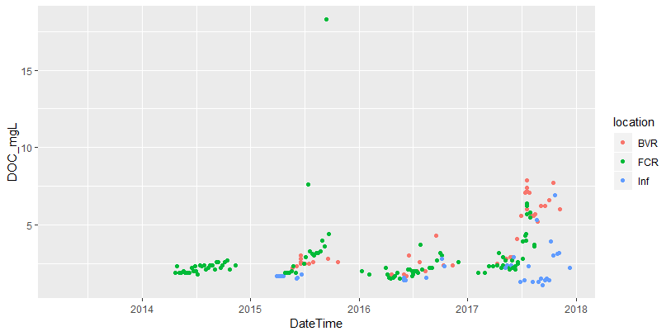
  2. Nitrate should decrease from BVR -> FCR (Sadro et al 2012)
     + Result: the opposite is seen in BVR -> FCR
       - Not a strong signal, but FCR appears to have slightly higher nitrate-ite levels than BVR
       - 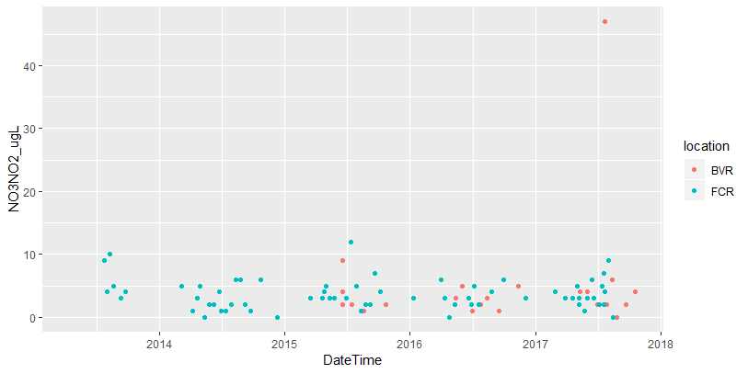
     + What about TN? (need to do more research to synthesize what literature says we should expect for how TN should change with increases in lake chain number or hydrologic connectivity)
       - Result: we see slightly higher levels of TN in BVR than in FCR
         * Overall, inflow TN is much lower than reservoir TN, but would be good to account for per area
       - 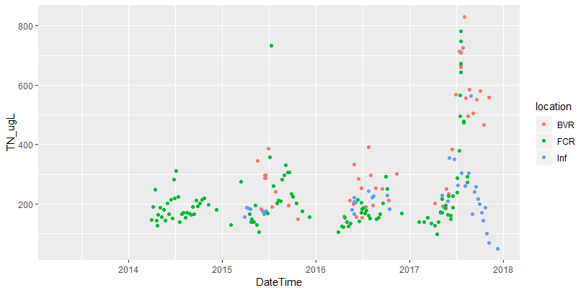
  3. What about TP?? (need to read more lit to get a good handle on what we would expect the direction of this relationship to be)
     + Result: TP increases with reservoir continuum
       - FCR is consistently higher than BVR
       - Inflow is in general higher than FCR
         * Which is very interesting considering the area of FCR vs. inflow
       - Signal is similar but less clear with SRP
     + 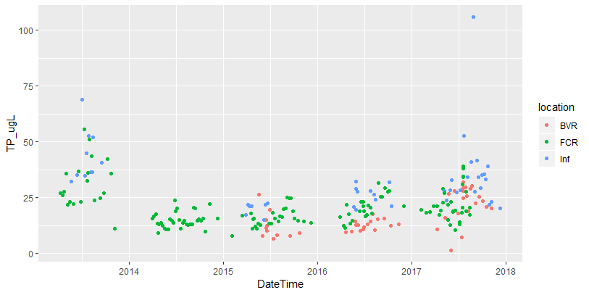
     + 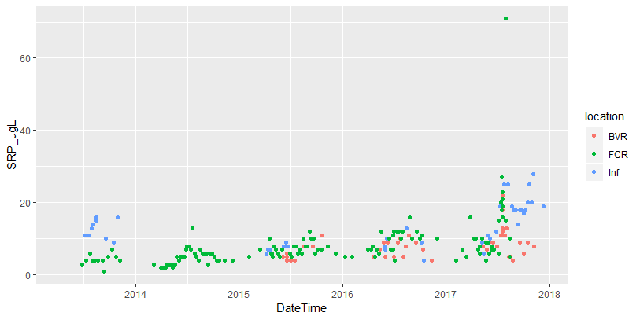
  4. N:P should decrease from BVR -> FCR
     + Result: we see this pretty clearly in BVR and FCR!
       - BVR consistently has higher TN:TP
       - BVR P-limited?
       - TP and SRP are also lower in BVR

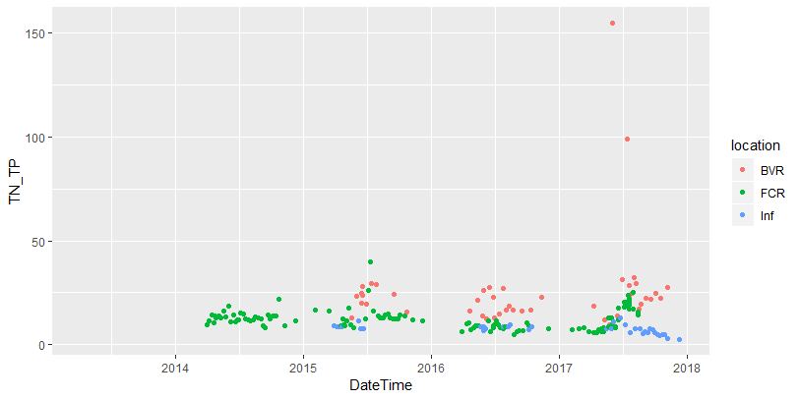

* **Hypothesis 2: Reservoirs will act as sinks for nutrients in response to high flow (storm) events and source for nutrients during low flow periods**
  + A quick and dirty: Pairing nitrate levels with discharge over the same time period
    - We see huge spikes in nitrate-ite at inflow following max discharge events
    - But if you look at the figure of nitrate-ite at just FCR and BVR, we do not see increases after max discharge events (except for 2017)—I can maybe even see a decrease in nitrate-ite concentrations at FCR following major discharge events (e.g., 2014, 2015, and 2016)
  + 